Accepting credit cards: Setup

Configuration steps:
First, plug card reader into computer. Let the computer recognize the device and install the appropriate drivers, as it would do for a receipt printer (should happen automatically).

Then in Workflows, go up to Preference > Peripherals and select Mag Stripe Configuration:

Check the “Mag stripe reader is available” box and select the device from the dropdown
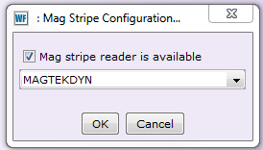

The credit card device is now configured to take payments.

Place the newly configured card reader in a location where the patrons can swipe the card themselves.

Just like with the online catalog, library staff should not handle the patron’s credit card. Instead, instruct the patron to swipe the card themselves.

Accepting credit cards: Paying Fines

Using the Pay Fines Wizard:
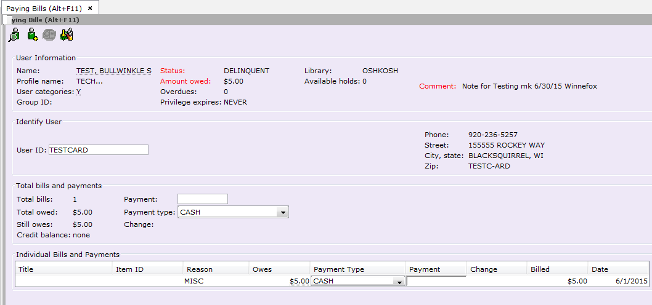
A credit card payment can be done in “Total bills and payments” or in each individual bill and payment.

Enter the amount the patron wants to pay on their credit card.

Payment Type is CARDSWIPE

IMPORTANT: $1.00 minimum for payment with a credit card.

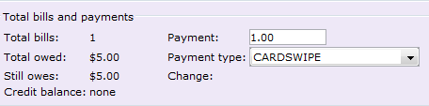

Click Pay Bills:

A popup box will appear:

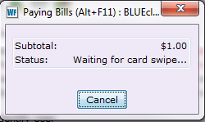

Have patron swipe card.

If the card is swiped backwards, too slowly, or is jarred during the swipe, an error box appears:

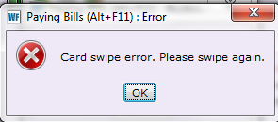

Click OK and try swiping again.

A successful swipe will have the box’s status change from “Waiting for card swipe” to “Processing”:
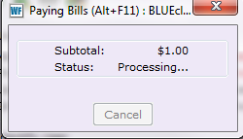

When completed, the box will vanish and the patron’s receipt will print. At that point, you may click Pay More Bills or Make Payments for Another User.

